**Project Documentation**

**Task:** Create a Frontend Project using REACT where a user need to fill a form and on Submit the form data of every submitted form is shown on the another page.

**Project Title:** Book Details

**Technologies Used :** HTML, CSS, JS, REACT.

**Github Link :** *https://github.com/tanya-03/ST_4.git*

**Project Description:**

This project is a form type react project made for the taking the entries of Book details and storing and displaying in a tabular form.

**How to Install and Run the Project:**

This is a React application and hence needs to be forked and cloned in your system and then Run it with the code **npm start** in the console with pre- requisite of nodejs installed in your system and the directory should be the one in which **package.json** file is present.

*First Page*

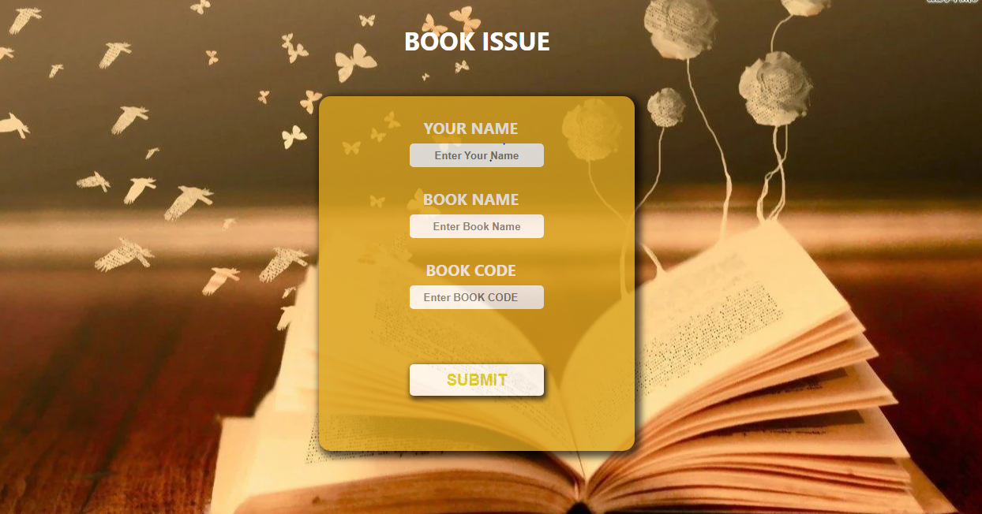

*Second Page*

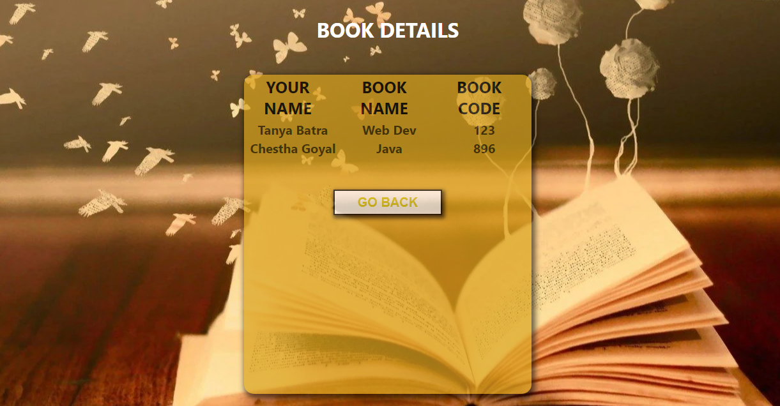

**Conclusion & Scope of Improvement:**

This react app is just a part of a Book website which only serves the purpose of taking the Booking details. Soon it will be combined and its purpose will be fulfilled.